Task 3.1P – SIT 788 – Damon Vizl – [s22354885@deakin.edu.au](mailto:s22354885@deakin.edu.au)

Target Domain and Application

The Target Domain analysed in this report is Transport. The specific application to be discussed is Adaptive Cruise Control.

The paper I used for this fuzzy application analysis was *Adaptive Cruise Control Using Fuzzy Logic* (Lloyd, 2021)

Fuzzy Logic Application

The application of fuzzy logic fits tightly with the problem of Adaptive Cruise Control. The inputs selected for this problem are:

* Quality of the vehicle (Acceleration, braking)
* Driver State (biological vision, reaction speed, emotional state, fatigue)
* Environment Quality (visibility, stability, road type)
* Current Speed
* Distance to object

As a lot of these inputs are broad, subjective and categorical; fuzzy logic suits the problem well.

The quality of the braking and acceleration cannot easily be binarily defined along with reaction speed, emotional state and fatigue.

The road type, visibility and stability are also categorical inputs that cannot be easily assigned an numeric value.

The advantages of using the Fuzzy Logic system in this application is it allows a solution that meets a broad range of variables, can take a wide range of inputs and intuitively output a desired outcome.

Fuzzy Pipeline

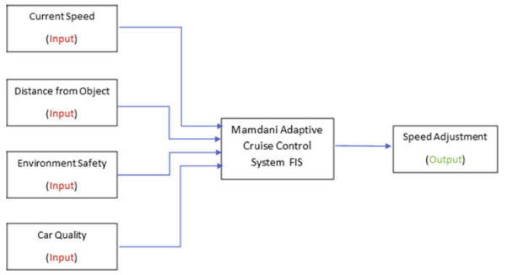

**Figure 1 – FIS Model**

Figure 1 shows the pipeline of the Fuzzy System implemented. We can see the inputs on the left, the Fuzzy Inference System (FIS) being used (Mamdani) and the Crisp output being the speed adjustment.

The Mamdani FIS provides the fuzzification and defuzzification process. Various defuzzification methods were used including Centroid, Bisector, Smallest of Maximum, Middle of Maximum and Largest of Maximum. All these methods were tested and he results compared against each other. Centroid was the defuzzification method chosen for this application.

Rules of the Fuzzy System

The rules of this system were based on three different variation of fuzzy set membership. These being:

* Triangular,
* Trapezoidal, and
* Gaussian.

The Gaussian membership functions were used for the middle intervals for speed and speed adjustment. A modified Triangular/Trapezoidal hybrid method was used for the other remaining features.

Testing of these rules and modification of the boundaries of the set memberships reduced the original rule count from 309 to 262, improving compute time which is integral in this safety application.

References

Lloyd, N, Khuman A (2021). *Adaptive Cruise Control Using Fuzzy Logic*. Springer 2021 p191-219 <https://link-springer-com.ezproxy-b.deakin.edu.au/book/10.1007/978-3-030-66474-9>